Understanding microglia-neuron crosstalk by characterizing microglial contamination in human and mouse Patch-seq datasets

Keon Arbabi*1,3, Yiyue Jiang *1, Derek Howard1, Daniel Felsky1,2,3, Shreejoy Tripathy1,2,3,4

* indicates equal contribution

1) The Krembil Centre for Neuroinformatics, Centre for Addiction and Mental Health, Toronto, ON, CA

2) Department of Psychiatry, University of Toronto, Toronto, ON, CA

3) Institute of Medical Science, University of Toronto, Toronto, ON, CA

4) Department of Physiology, University of Toronto, Toronto, ON, CA

# Abstract

Microglia are dynamic immune cells with diverse functional roles, including the regulation of neuronal excitability. Here, we leveraged an inconvenient truth of neuronal Patch-seq datasets — that they routinely display evidence of contamination by surrounding microglia — to better understand aspects of microglia-neuronal crosstalk. We first quantified the presence of microglial transcripts in Patch-seq datasets of human supragranular glutamatergic neurons and mouse GABAergic interneurons, revealing extensive off-target contamination. Variation in microglial contamination was explained foremost by donor identity in human samples, whereas neuronal identity contributed most among mice. Differential expression testing and enrichment analyses suggest that microglial contamination in Patch-seq is likely reflective of activated microglia and that these signatures are distinct from those captured via single-nucleus RNAseq. Finally, neurons with greater microglial contamination differed markedly in their electrophysiological characteristics, including lowered input resistances and more depolarized action potential thresholds. Our results suggest microglial contamination contributes to cell- and donor-related electrophysiological variability and sheds light on how microglia might impact neurons *in vivo*.

# Introduction

Microglia are the innate immune cells of the central nervous system and exhibit a complex array of phenotypes and functions (Bachiller et al., 2018; Ginhoux et al., 2013). Microglia frequently interact with neurons and are important for regulating synaptic plasticity and neuronal activity in the healthy brain (Cornell et al., 2022). For example, pruning synapses is crucial for the refinement of neuronal circuitry during development as well as learning and memory in the adult brain. This process is carried out by phagocytic microglia and regulated by several immune-related signaling pathways (Lehrman et al., 2018; Sellgren et al., 2017; Wang et al., 2020). Microglia are also active surveyors of neural circuits in the mature brain where they maintain homeostasis of local neuron activity (Badimon et al., 2020). If changes such as neuronal injury are detected, microglia transition into an active state and secrete proinflammatory cytokines and reactive oxidative species (Koss et al., 2019; Spencer et al., 2016). These activated microglia may then modulate the intrinsic excitability of neurons in a cell type- and region-specific manner (Yamamoto et al., 2019; Yamawaki et al., 2022).

Despite a rapidly growing body of information linking microglia to neuronal function and dysfunction, characterizing the spectrum of possible microglia states and their biological roles has been challenging. For example, efforts to transcriptomically survey microglia at the single-cell resolution often inadvertently perturb these cells [(Marsh et al., 2022)](https://www.zotero.org/google-docs/?H1TnEM). While single nucleus based efforts suffer to a lesser degree from these confounds, they often fail to detect transcripts that are distinctive markers of microglial states, including genes related to microglial activation [(Thrupp et al., 2020)](https://www.zotero.org/google-docs/?OsMaL7).

Patch-seq is a recent method that combines patch-clamp electrophysiology with single-cell RNA-sequencing (scRNA-seq) [(Lipovsek et al., 2021)](https://www.zotero.org/google-docs/?MW0Vw8). Unlike more traditional methods for scRNAseq that first rely on cell dissociation, Patch-seq is unique in that the patch pipette itself is used to carefully harvest mRNA from the cytoplasm and nucleus of the targeted cell following electrophysiology [(Cadwell et al., 2017; Lipovsek et al., 2020)](https://www.zotero.org/google-docs/?i5jENE). Patch-seq is transformative because it enables assaying morpho-electric and transcriptomic features from the same cell and can serve as a “Rosetta Stone,” enabling translating between newer gene expression-based and historical cell type atlases [(Berg et al., 2021](https://www.zotero.org/google-docs/?MP0rw8), [Gouwens et al., 2019](https://www.zotero.org/google-docs/?MIYU5U), [Scala et al., 2020)](https://www.zotero.org/google-docs/?YefTRt).

A major challenge with Patch-seq, however, is that off-target cellular contamination from surrounding cells is often prevalent in these datasets. We initially reported the paradoxical presence of high levels of gene expression markers of non-neuronal cells, including microglia, in multiple Patch-seq datasets of electrophysiologically-confirmed neurons [(Tripathy et al., 2018)](https://www.zotero.org/google-docs/?VZvKKO). Because this contamination was observed in datasets collected from freshly obtained acute brain slices but not those from sparsely-plated cell cultures, we reasoned that such contamination is likely due to the physical contact of the patch pipette with processes of other cells in proximity to the recorded cell. Since our initial report, a number of Patch-seq studies have corroborated these findings, and in particular, that neuronal Patch-seq datasets appear especially impacted by microglial contamination [(Berg et al., 2021; Lee et al., 2021a; Scala et al., 2020)](https://www.zotero.org/google-docs/?W6yV68).

Here, our goal was to comprehensively characterize microglial contamination in Patch-seq datasets. Specifically, we wanted to survey its extent in high-quality datasets of Patch-seq profiled neurons from human and mice brain slices. We further asked if there are particular aspects of donor and neuronal identity that most contribute to microglial contamination. We aimed to characterize the specific transcriptomic signature of microglial gene expression in Patch-seq, and further, to relate this signature to known profiles of microglial activation states. Critically, we aimed to learn if microglial contamination is associated with aspects of altered electrophysiological activity of the recorded neuron. Our findings suggest that the inadvertent sampling of microglia is indeed widely present, in particular, among Patch-seq samples derived from human neurosurgical biopsies. Furthermore, our analyses indicate that microglial contamination is likely reflective of a distinct microglial activated state and associated with altered cellular electrophysiology.

# Methods

## Datasets

All datasets were obtained from the Allen Brain Institute Cell Types Database (<http://celltypes.brain-map.org/>).

### Patch-seq

We made use of data from human Patch-seq experiments detailed previously [(Berg et al., 2021)](https://www.zotero.org/google-docs/?3tsH9G). Briefly, surgical tissues were obtained from local hospitals and transported in artificial cerebral spinal fluid to a laboratory, where acute slices were prepared for patch clamp recording. Upon completion of the electrophysiology experiment, negative pressure was applied to the patch pipette to extract the cytosol and nucleus of the target cell (Figure 1B). The SMART-Seq v4 platform was used for cDNA amplification and library construction, followed by sequence alignment. Single-cell transcriptomes from Patch-seq samples were subsequently mapped to a reference taxonomy based on single-nucleus RNAseq data from the human medial temporal gyrus [(Berg et al., 2021](https://www.zotero.org/google-docs/?Cu0UWK); [Hodge et al., 2019)](https://www.zotero.org/google-docs/?4LolPH). RNA-sequencing metadata and counts data were downloaded for our analyses (accessed 05/10/2021). A total of 278 supragranular glutamatergic neurons from MTG in 48 subjects (18 female) were included. Brain slices not used for slice electrophysiology were also characterized using immunohistochemistry for various protein markers, including IBA1, marking microglia, and GFAP, marking astrocytes.

We also made use of data from mouse Patch-seq experiments detailed previously [(Gouwens et al., 2020)](https://www.zotero.org/google-docs/?MXzScj). Cell recordings were performed using male and female mice between the ages of P45 and P70. Multiple Cre-driver lines were used to target cells for morphoelectric and transcriptomic characterization. Single-cell transcriptomes from patch-seq samples were then mapped to a reference taxonomy of dissociated neuronal cells from mouse VISp [(Tasic et al., 2018)](https://www.zotero.org/google-docs/?FTMJ4i). RNA-sequencing metadata and counts data were downloaded for further analyses (v2, released 07/01/2020). A total of 4,270 GABAergic interneurons sampled from visual cortex in 1,040 mice (468 female) were included.

### Single-cell and single-nucleus RNA-seq derived from dissociated cells and nuclei

Gene expression patterns from Patch-seq samples were compared to cell dissociation-based single-cell and single-nucleus RNA-seq datasets. [Hodge et al. (2019)](https://www.zotero.org/google-docs/?udRQ9C) used snRNA-seq and multiple clustering approaches to describe the cell type taxonomy of 15,928 nuclei from human MTG. [Yao et al. (2021)](https://www.zotero.org/google-docs/?yNWa2f) used scRNA-seq to profile ~1.3 million cells from the adult mouse isocortex and hippocampal formation to generate a transcriptomic cell-type taxonomy. Cells and nuclei characterized using SMART-seq from both datasets were downloaded and used for the present analyses (accessed 09/25/2021).

## Microglial contamination score

To quantify the amount of microglial contamination for each Patch-seq cell, we applied previously described methods for assessing the quality of Patch-seq transcriptomic data [(Lee et al., 2021b; Tripathy et al., 2018)](https://www.zotero.org/google-docs/?7PH1jW). Specifically, we made use of cell type-specific markers for human and mouse neocortical neurons calculated in [Lee et al. (2021)](https://www.zotero.org/google-docs/?ANXVzV) (<https://github.com/AllenInstitute/patchseqtools>). These markers describe both “on” markers, or genes that are highly and ubiquitously expressed in neurons of interest relative to other cell types. “Off” markers are expected to be expressed at low levels in Patch-seq cells, and if expressed together with “on” markers, are an indicator of possible cellular contamination. [(Lee et al., 2021b)](https://www.zotero.org/google-docs/?PoksGH) calculated both types of markers using the single-cell and single-nucleus RNA-seq datasets from dissociated cells and nuclei described previously [(Hodge et al., 2019; Tasic et al., 2018)](https://www.zotero.org/google-docs/?1VtNMB), which can serve as ground truth expression data for comparison with Patch-seq cells.

Using the definitions described in [(Lee et al., 2021b; Tripathy et al., 2018)](https://www.zotero.org/google-docs/?3sQy9D), we calculated the *contamination score* of microglia *(M)* in a neuron subtype of interest *(N)*, as:

The expression of microglia markers in a Patch-seq cell *c* are compared to the expected expression in reference data from which the markers were derived. To do this we take the summed normalized expression (log2 CPM) of 50 microglia markers in a cell of *N (Pc_N, M)* and subtract the median microglia marker expression in dissociated cells of type *N (dN_M)*. If this numerator is negative (for example, if cell *c* expresses no microglial markers but *dN_M* is positive), it is set to 0 in these cases (indicating no detected contamination). The denominator scales this value by the expected expression of microglial markers in reference microglia. The contamination score can thus be interpreted as a ratio of the excess off-target microglial expression, scaled between 0 and 1 (where 1 indicates that the cell expresses off-target microglial expression at a level similar to actual microglia).

## Visualizing Patch-seq gene expression

Gene expression from human and mouse Patch-seq cells was processed according to the standard Seurat V3 workflow [(Butler et al., 2018; Stuart et al., 2019)](https://www.zotero.org/google-docs/?Yf3Y89). All available cells for human and mouse were included in the following steps. Best practices for processing Patch-seq data typically involve filtering out genes that are highly expressed in non-neuronal cell types, however this step was omitted to gauge the extent of off-target contamination. Only mitochondrial genes and genes of uncertain function were filtered out prior to normalization. The top 2000 variable features (5000 for mouse) were identified, followed by scaling, linear dimensionality reduction, and clustering using the default parameters. Cells were visualized by projection onto Uniform Manifold Approximation and Projection (UMAP) space.

## Associations between microglial contamination and donor, cell type, and tissue characteristics

Univariate relationships between microglia contamination score and available Patch-seq metadata were described, including neuron transcriptomic-type, cell soma normalized depth (normalized depth of cell soma from the pial surface), and, in human samples, histological markers of tissue pathology. Histological pathology scores for IBA1 and GFAP protein expression were included as the only markers not skewed heavily towards zero, and were binned by marker score (low ≤ 1, high > 1), as performed in [(Berg et al., 2020)](https://www.zotero.org/google-docs/?pLlji7). Given the large number of mouse transcriptomic types at the cluster resolution, we aggregated closely related cell clusters by summarizing t-types using the subclass designation and the first marker gene (e.g., Sst Hspe Sema3c → Sst Hspe).

To further explain the influence of these characteristics with off-target microglial expression in Patch-seq samples, we employed mixed effects models. Only cells with data available for the variables of interest were included, and cell types with fewer than 20 cells were excluded. The following model was used for the human Patch-seq data:

microglial contamination score ~ biological sex + medical condition + scale(age) +

scale(cell soma normalized depth) + transcriptomic type + IBA1 protein + GFAP protein + (1 | donor id)

And for the mouse Patch-seq data:

microglial contamination score ~ biological sex + scale(age) +

scale(cell soma normalized depth) + transcriptomic type + (1 | donor id)

We estimated the proportion of variation in microglial off-target contamination predicted by each variable. The coefficient of determination (R2) for each fixed effect (every term except donor id) was iteratively calculated by taking the difference between the marginal R2 value of the full model and the marginal R2 value of a reduced model, in which the fixed effect of interest was replaced by a random intercept. Marginal R2 was calculated using the method described by [(Nakagawa et al. 2017)](https://www.zotero.org/google-docs/?6JVD1d) and implemented in theMuMInpackage [(Burnham and Anderson, 2010)](https://www.zotero.org/google-docs/?0l3wKp). The variance explained by the random effect of donor id was estimated by subtracting the marginal R2 from the conditional R2 of the full model.

## Differential gene expression analysis

To characterize the transcriptional signature associated with off-target microglial contamination in Patch-seq data, we performed differential expression testing. For the human data, high and low contamination groups were defined by the top and bottom quartiles of Patch-seq sampled neurons ranked by contamination score, respectively. For the mouse data, deciles were used to adjust for the smaller fraction of cells with high contamination. In each dataset, differential expression tests between these groups were performed with DESeq2 [(Monat et al., 2019)](https://www.zotero.org/google-docs/?dVvknk) using the FindMarkers function with default settings in Seurat v3. Differentially expressed genes (DEGs) were defined as having >2.5 or <-2.5 log2 fold-change and p-value < 0.01.

For comparison, we also performed differential expression testing between groups of microglia and neurons in the reference single cell and single nucleus RNA-seq datasets. We selected neuronal transcriptomic types that most closely matched those surveyed in the human and mouse Patch-seq datasets. For the Yao dataset, cells labeled “Micro-PVM” at the subclass level in all brain regions (N = 178) and “GABAergic” at the class level in VIS and VISp (N = 6846) were compared with DESeq2 as described above. For the Hodge dataset, cells labeled “Microglia'' at the subclass level (N = 246) and cells with cluster labels including “Exc L2-3”, “Exc L2-4”, and “Exc L3-4” in MTG (N = 3609) were compared. DEGs from these tests were selected as described above.

The functional context of DEGs was explored with gene set enrichment analysis. We include 19 unique microglial gene lists from 4 publications pulled from the literature, selected for their inclusion of homeostatic and activated microglia populations from both human and mouse. Friedman et al. performed a meta-analysis of purified mouse CNS myeloid cells across a wide range of disease models and identified distinct modules of co-regulated genes associated with lipopolysaccharide (LPS) injection, interferon signaling, and neurodegeneration. In a single-cell dataset of a mouse model of Alzheimer’s disease (AD), each module represented distinct types and activation states of microglia [(Friedman et al., 2018)](https://www.zotero.org/google-docs/?qev4Ec). Keren-Shaul et al. identified disease-associated microglia (DAM) in an AD-transgenic mouse model that potentially restricts neurodegeneration [(Keren-Shaul et al., 2017)](https://www.zotero.org/google-docs/?vdBaue). Mathys et al. confirmed the presence of DAM and identified several other disease stage-specific microglial states in a mouse model of AD-like neurodegeneration [(Mathys et al., 2017)](https://www.zotero.org/google-docs/?6b5An4). Olah et al. performed scRNA-seq to explore the population structure of live microglia purified from surgically resected human cortex and characterized nine clusters of microglia encompassing states specific to homeostasis, proliferation, response to cellular stress, and responses to injury and disease [(Olah et al., 2020)](https://www.zotero.org/google-docs/?8bVy00). These findings reflect the heterogeneity of microglia, and the presence of activation and/or disease-related subtypes. Gene sets were directly acquired from supplemental materials. If human or mouse genes were not provided by the authors, the provided set was converted using the getLDS() function from the biomaRt package [(Durinck et al., 2005, 2009)](https://www.zotero.org/google-docs/?Udjq7Z). Cluster-defining genes provided by OIah et al. were filtered to those significantly downregulated in >6 other clusters to enhance specificity.

The enrichment of these gene sets in genes significantly upregulated (>2.5 log2 fold-change, p-value < 0.01) in high microglial contamination Patch-seq cells and reference scRNA-seq microglia was determined with the hypergeometric test implemented by the HypeR package [(Federico and Monti, 2020)](https://www.zotero.org/google-docs/?70AanT).

## Electrophysiology analyses

Raw electrophysiological traces from the human [(Berg et al., 2021)](https://www.zotero.org/google-docs/?L55mKk) and mouse [(Gouwens et al., 2020)](https://www.zotero.org/google-docs/?zJNUJf) Patch-seq experiments were obtained from DANDI (dataset IDs: 000209 and 000020). Stimulation protocols consisted of long-square hyperpolarizing and depolarizing current injections. The Intrinsic Physiology Feature Extractor (IPFX) toolbox [(Lee et al., 2021a)](https://www.zotero.org/google-docs/?qqsQuB) was used to extract electrophysiological features from each recorded neuron, similar to as described previously [(Moradi Chameh et al., 2021)](https://www.zotero.org/google-docs/?AihuFQ). Extracted features include subthreshold features (i.e., input resistance, sag ratio), action potential properties (i.e., action potential half-width, threshold time and voltage) derived from the rheobase spike, as well as multi-action potential spike train features derived from the IPFX-defined “hero” sweep (i.e., adaptation index). Action potential amplitude was defined as the difference between peak and threshold voltage and after hyperpolarization amplitude was defined as the difference between action potential threshold and the fast action potential trough.

We used a statistical approach to ask how microglial contamination is associated with cell-to-cell variability in electrophysiological features, after controlling for other aspects of cellular and donor identity. Specifically, we used a mixed effects model, where, for human cells:

electrophysiology feature ~ microglia contamination score + scale(cell soma depth from pia) + (1| neuron transcriptomic type) + (1 | donor id)

And for mouse cells:

electrophysiology feature ~ microglia contamination score + (1| neuron transcriptomic type) + (1 | donor id)

We used a log10 normalization to scale input resistance, rheobase, and action potential half-width and all electrophysiology features were standardized prior to modeling. We chose not to standardize microglia contamination scores to enable direct comparisons of effects between humans and mice, as these have very different standard deviations in microglial contamination scores.

# Results

## Strategy for assessing the impact of microglial off-target contamination in neuronal Patch-seq samples

To study the extent and impact of microglial off-target contamination in Patch-seq experiments we used two dataset sampling human supragranular glutamatergic neurons and mouse GABAergic interneurons (Figure 1A), previously published by the Allen Institute for Brain Sciences [(Berg et al., 2021; Gouwens et al., 2020)](https://www.zotero.org/google-docs/?5xOQue). These datasets were selected in part due to their large size, reflecting hundreds and thousands of neuronal samples, respectively. In addition, these datasets are considered to be high-quality and follow extensive internal optimization procedures, including rigorous efforts towards quality control [(Lee et al., 2021a)](https://www.zotero.org/google-docs/?7RN3jD). Lastly, the availability of high-quality cell-dissociation based single-cell and single-nucleus transcriptomes from parallel samples (Figure 1A; also collected by the Allen Institute, [Hodge et al., 2019; Yao et al., 2021)](https://www.zotero.org/google-docs/?GTahKy) enables rigorous comparisons between Patch-seq based and cell dissociation-based gene expression profiles.

## Microglial off-target contamination is widely present in human and mouse Patch-seq neuronal transcriptomes and drives unbiased clustering

To quantify the levels of microglial off-target contamination in Patch-seq-sampled neurons, we first examined the expression of cell type-specific marker genes. We observed that Patch-seq neuronal samples expressed high levels of the expected marker genes, for example, *SV2B* and *SATB2* in human superficial pyramidal cells (Figure 1C, top row) and *Sst*, *Gad1*, and *Gad2* in mouse somatostatin interneurons (Figure 1F, top row). However, further investigation revealed that many Patch-seq neuronal transcriptomes expressed high levels of multiple microglia-specific markers which are not expected to be expressed in neurons (see Methods, [Lee et al., 2021a](https://www.zotero.org/google-docs/?VBtk7W)). Such markers include *C3* and *C1QB* in human samples (Figure 1C, middle row) and *C1qb* and *Tyrobp* in mouse samples (Figure 1F, middle row). Because of the widespread upregulation of many unexpected microglia-specific transcripts in Patch-seq neuronal samples, we reason that these likely reflect the inadvertent sampling of mRNA from microglial cellular processes via the patch-pipette (Figure 1B), as opposed to the endogenous upregulation of microglia-specific transcripts by the sampled neuron. We note that the expression of astrocyte-specific markers was generally rare in both human and mouse samples (Figure 1C, 1F, bottom row), suggesting that astrocytes are likely not a major source of off-target cellular contamination in these samples.

To obtain a single value reflective of the extent of off-target microglial contamination, we calculated microglial contamination scores for each Patch-seq neuronal cell, as defined previously in [(Lee et al., 2021a; Tripathy et al., 2018)](https://www.zotero.org/google-docs/?FLyL2V).These scores provide an interpretable scalar value between 0 and 1, where 0 indicates little-to-no detected microglial contamination and 1 indicates a very high degree of contamination at levels similar to those expressed by microglia sampled via single-nucleus (human) or single-cell (mouse) RNAseq.

We asked if off-target microglial contamination is sufficient to drive unbiased transcriptional clustering of Patch-seq neuronal samples. Following standard workflows for single-cell analyses (see Methods), we found that both human and mouse Patch-seq neuronal samples exhibited strong visual evidence of transcriptomic clustering, in part, according to their levels of off-target microglial contamination (Figure 1D, 1G). On average, we found that human Patch-seq neuronal transcriptomes appeared considerably more contaminated by microglia than in the mouse (Figure 1E, 1H; human: 0.34 ± .25, mouse: 0.19 ± .22, mean ± SD, normalized microglia contamination scores).

**Figure 1. *Patch-seq transcriptomes of human and mouse neurons express off-target expression of microglial marker genes at levels sufficient to drive unbiased clustering.* (A)** Overview of datasets used in study, including two recent Patch-seq datasets of cortical neurons in human and mouse, with comparisons made to dissociated human single nucleus and mouse single cell RNA-sequencing datasets, respectively. **(B)** Schematic illustrating manipulation of patch-pipette towards a neuron of interest, and collection of mRNA from cell nucleus, cytoplasm, and possibly surrounding environment via the patch-pipette. **(C,F)** Gene expression profiles for superficial glutamatergic neurons (C) or SST interneurons (F)for various cell type-specific markers. Each row represents a neuron, ordered from top to bottom by decreasing microglial contamination score. **(D,G)** Low- dimensional visualization of transcriptomes from neuronal Patch-seq samples clustered by most variable gene expression and color-coded by microglial contamination score for human pyramidal cells (D), and mouse GABAergic interneurons (G). **(E,H)** Histograms of microglial contamination scores for human (E) and mouse (H) neurons, dashed lines indicate population mean.

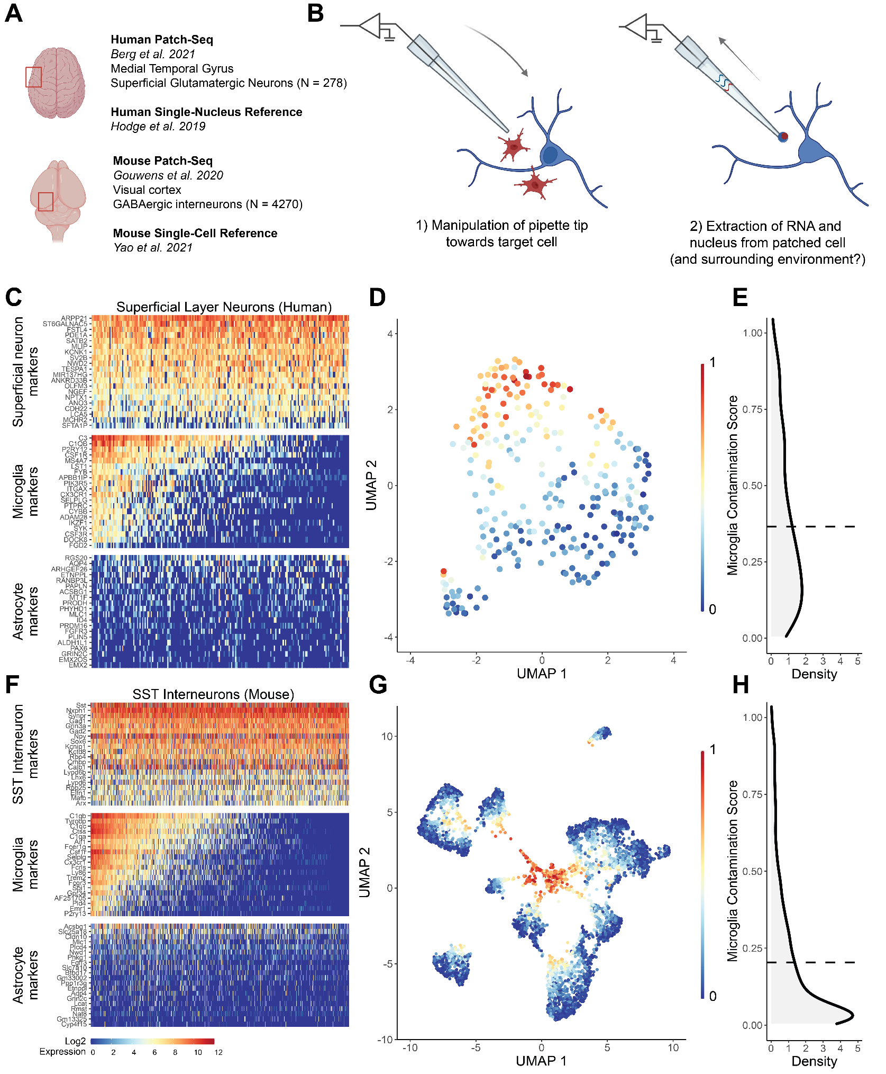

## Inter-donor differences and neuronal identity explain the most variation in microglial off-target contamination

We next wanted to understand how experimental characteristics, like cell type identity, donor characteristics, and tissue quality, might correlate with off-target microglial contamination in Patch-seq cells. Among human Patch-seq sampled superficial pyramidal neurons, we found samples collected from different neurosurgical donors varied considerably in the levels of microglial contamination (Figure 2A, Kruskal-Wallis ANOVA p = 4.3 * 10-6). In contrast, we found a non-significant trend between transcriptomic cell identity of the sampled neuron (t-type) and microglial contamination scores (Figure 2B, Kruskal-Wallis ANOVA p = 0.22). Utilizing data from immunohistology performed on brain slices not used for electrophysiological characterization, IBA1 and GFAP protein expression (markers of microglia and astrocytes respectively) was modestly associated with increased microglial contamination (GFAP: Figure 2C left, Kruskal-Wallis ANOVA p = 0.067; IBA1: Figure 2C right, Kruskal-Wallis ANOVA p = 0.10). While the prior association between transcriptomically-inferred microglial contamination and IBA1 protein expression is modest, this serves as an independent confirmation of our interpretation of increased microglial expression in these samples from these donors.

Among Patch-seq sampled GABAergic cortical interneurons from mice, we found that different cell types exhibited different levels of microglial contamination (subclass: Figure 2D, cluster: Figure 2E). We observed lower levels of microglial contamination among Vip and Lamp5 subclasses and comparatively higher levels in Sst, Sncg, and Serpinf subclasses (Figure 2D, Kruskal-Wallis ANOVA p = 1.0 * 10-8). Even among more fine-grained neuronal subtypes (i.e., clusters), we observed considerably different levels of microglial contamination among clusters from the same parent subclass (Figure 2E, Kruskal-Wallis ANOVA p = 2.2 * 10-8). For example, we observed the highest levels of microglial contamination among Pvalb Vipr2 cells (i.e., chandelier cells; [Gouwens et al., 2020)](https://www.zotero.org/google-docs/?2Lxdcr) but much lower levels among other Pvalb cells, including Pvalb Reln cells, which comprise more traditional fast-spiking Pvalb interneurons. This analysis is suggestive of the potential for differential vulnerability of various cortical interneuron types to surrounding microglia.

To further quantify associations between these experimental variables and microglial off-target contamination, we used a random effects model, allowing us to statistically model correlations between Patch-seq sampled neurons recorded from the same donor (see Methods). Among the human pyramidal neuron samples, donor identity, by far, explained the most neuron-to-neuron variability in microglial off-target contamination (R2 = 25.4%), followed by cell type identity (R2 = 3.34%), and other donor specific factors such as levels of GFAP and IBA1 protein expression (R2 = 2.08% and 1.00%). Other factors, such as donor age at time of surgery, sex, and cell soma depth from pia, were only weakly explanatory for microglial off-target contamination (R2 < 1%). Among mouse samples, we found that the most important factor associated with microglial off-target contamination was cell type identity (R2 = 8.95%), followed by donor (R2 = 5.37%). Similarly, in mice, like the human analyses of pyramidal neurons, animal sex and age appeared to explain little variability (R2 = 0.553% and 0.055%). In our mouse analyses, we chose not to include other factors like soma depth from pia, as these were not available for most sampled cells from mice. In total, considerably more neuron-to-neuron variation in microglial off-target contamination could be explained for human samples relative to mice (R2 = 32.7% for humans vs R2 = 14.9% for mice), perhaps in part reflecting the overall degree of greater microglial contamination among the human samples.

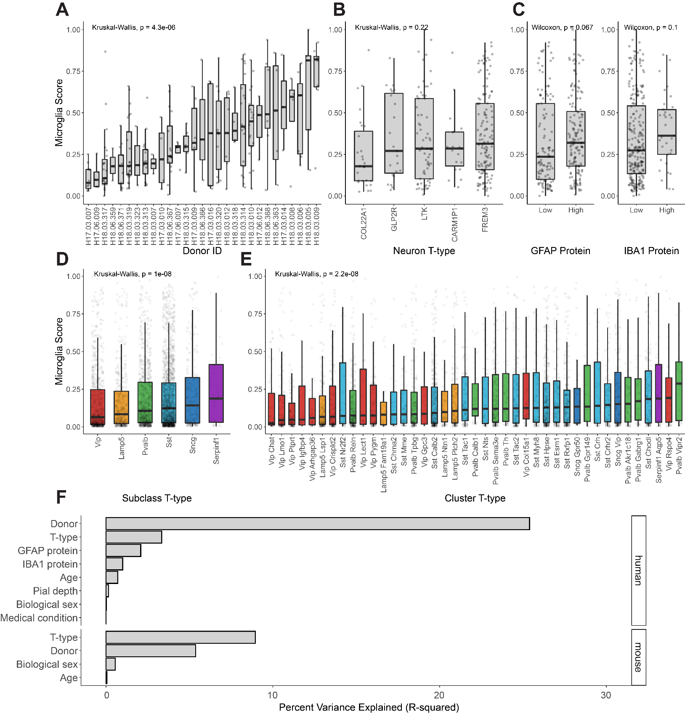

**Figure 2. *Associations between donor, cell type, and tissue characteristics with off-target microglial expression in Patch-seq samples.* (A,B,C)** Associations between microglia contamination scores (y-axis) estimated from human pyramidal neuron Patch-seq samples and neurosurgical donor identity (A), transcriptomically-inferred neuronal type identity (B), and GFAP (left) and IBA1 (right) protein expression assayed via immunohistochemistry (C) performed on brain slices not used for Patch-seq characterization (low ≤ 1, high > 1). **(D, E)** Associations between microglia contamination scores (y-axis) estimated from mouse GABAergic interneuron Patch-seq samples and interneuron cell type identity, summarized at either the subclass level (D)or cluster level (E). (**F)** Estimated percent variance explained (R-squared) in microglial contamination scores among human (top) and mouse samples (bottom) by various factors, including donor identity, neuronal cell type identity (t-type), age, sex, sample depth from pial surface (Pial depth), medical condition (epilepsy or tumor), IBA1 or GFAP protein expression, biological sex).

## The microglial transcriptomic signature in Patch-seq is reflective of a distinct neuro-inflammatory state

We next sought to identify any distinctive transcriptomic characteristics of microglial contamination in Patch-seq. In particular, we wanted to investigate whether the detected off-target transcripts are reflective of particular microglia cell states, such as those observed in disease or in response to injury.

To determine the *“transcriptomic signature of Patch-seq microglial contamination”*, we first contrasted transcriptomes from neuronal samples with the highest microglial contamination to those with the lowest contamination (see Methods). In total, we saw that many genes were overexpressed in Patch-seq neurons with high contamination (Figure 3A, C, human: Supplementary Table 1, mouse: Supplementary Table 2), with 567 genes overexpressed in human samples and 422 genes overexpressed in mouse samples (log2 fold-change >2.5; p-value < 0.01). Interestingly, we tended not to see genes overexpressed in neuronal samples with low microglial contamination relative to those with higher contamination. Next, we defined a *“general microglia transcriptional signature”*, where we used available gene expression reference profiles from dissociated single-nucleus (human) or single-cell (mouse) RNAseq to identify genes overexpressed in microglia in comparison to neurons. We identified 797 such genes in human and 1276 genes overexpressed in mouse microglia. Lastly, we defined a “*Patch-seq distinct microglial signature”* by identifying genes from the *“transcriptomic signature of Patch-seq microglial contamination”* signature that were not also overexpressed in the *“general microglia transcriptional signature”*.

Many genes were identified in the Patch-seq distinct microglial signature, which appeared specific to samples with high levels of microglial contamination in Patch-seq but not dissociated microglia relative to neurons; for example, we saw 292 such genes in humans and 46 such genes in mice (Figure 3B, D). While this analysis might suggest a unique transcriptional signatures in humans relative to mice, there is likely a greater difference between microglial transcripts sampled via Patch-seq in comparison to those sampled via single-nucleus (human) versus single-cell dissociation (mouse), as recent reports have suggested single-nucleus RNAseq is especially limited in the context of microglia-related analyses [(Thrupp et al., 2020)](https://www.zotero.org/google-docs/?XHFbQi). In total, we identified 14 genes distinctive of a Patch-seq distinct microglial signature that were shared between both human and mouse, including *Il1b*, which encodes for a pro-inflammatory cytokine linked to neuroinflammation [(Pallio et al., 2021)](https://www.zotero.org/google-docs/?XTxsQr); *Nfkb2,* which transcriptionally induces pro-inflammatory cytokines and acts upstream cellular processes like cell differentiation and the regulation of neuroinflammation [(Liu et al., 2017)](https://www.zotero.org/google-docs/?sJX3Rp); *Igta5*, which encodes for a subunit of interferon alpha typically enriched in activated microglia [(Benmamar-Badel et al., 2020)](https://www.zotero.org/google-docs/?ADgI8j)*; Csf1,* induces microglial proliferation and survival and is upregulated during injury or disease [(Redlich et al., 2011)](https://www.zotero.org/google-docs/?hSOy5W); and *Pmaip1* is a pro-apoptotic gene that typically arises after injury [(Pan et al., 2022)](https://www.zotero.org/google-docs/?W6QzWH).

To elaborate on the transcriptional signatures associated with Patch-seq microglial contamination, we performed enrichment analyses of several published reference gene sets that capture diverse microglial states. We compared Patch-seq signatures to our general microglial signatures, to better understand how they may differ.

Among human patch-seq samples, we found evidence for an activated, inflammatory microglial signature among Patch-seq samples with high microglial contamination. Specifically, we found that the transcriptomic signature of Patch-seq microglial contamination was considerably more enriched for LPS- and neurodegeneration-related gene signatures as defined in [(Friedman et al., 2018)](https://www.zotero.org/google-docs/?AqRcsu) compared to the general microglia transcriptional signature (Figure 3E). Similarly, the microglial contamination signature was more enriched for microglial late response genes and disease-associated microglia (DAM) described by Keren-Shaul et al. and Mathys et al. (Figure 3F). Lastly, compared to microglia clusters identified in single-cell RNAseq from aged and Alzheimer’s human samples, the Patch-seq microglial signature was enriched for genes annotated to microglia-specific clusters 5, reflecting anti-inflammatory responses, and not enriched any others (Figure 3G). In mouse, we observed few major differences in enrichments between the Patch-seq microglial signature and the general microglial signature (Figure 3H-J), again suggesting fewer differences between microglia sampled during Patch-seq and reference microglial transcriptomes based on single-cell RNAseq. In summary, these analyses point to an activated, inflammatory microglial signature among Patch-seq samples with high microglial contamination, in part, which appears distinct from microglial signatures sampled via single-nucleus RNAseq.

**Figure 3. *Microglial contamination in Patch-seq reflects a distinct transcriptional signature related to microglia activation.* (A,C)** Venn diagrams indicating the number of genes that represent transcriptional signatures of general microglia in (A) human dissociated single-nucleus or (B) mouse single-cell datasets (blue border), transcriptional signature of Patch-seq microglial contamination in human or mouse Patch-seq datasets (red border), genes that are shared between the Patch-seq microglial and general microglia signatures (purple fill), and genes that are distinct to the Patch-seq microglial signature that are not also present in the transcriptional signatures of general microglia (yellow fill). **(B,D)** Volcano plots of transcriptional signature of Patch-seq microglial contamination (as in A, C), illustrating differentially expressed genes in Patch-seq datasets betweenhuman (B) and mouse (D) neuronal samples with high vs. low microglial contamination. Colors of points are as in A, C, where purple points denote differentially expressed genes (log2 fold-change >2.5; p-value < 0.01) that are shared with the general microglia transcriptional signature and yellow points denote genes that are distinct to microglial contamination in Patch-seq. **(E-J)** Enrichment analysis of general microglia (blue) and Patch-seq microglia (red) transcriptional signatures (as in A, C) intersected with gene sets of diverse microglial phenotypes and states from multiple data sources (titles in E-G). E-G denotes human microglia signatures and H-J denotes mouse. Dot size reflects the number of genes in each gene set. Dotted line is FDR = 0.05.

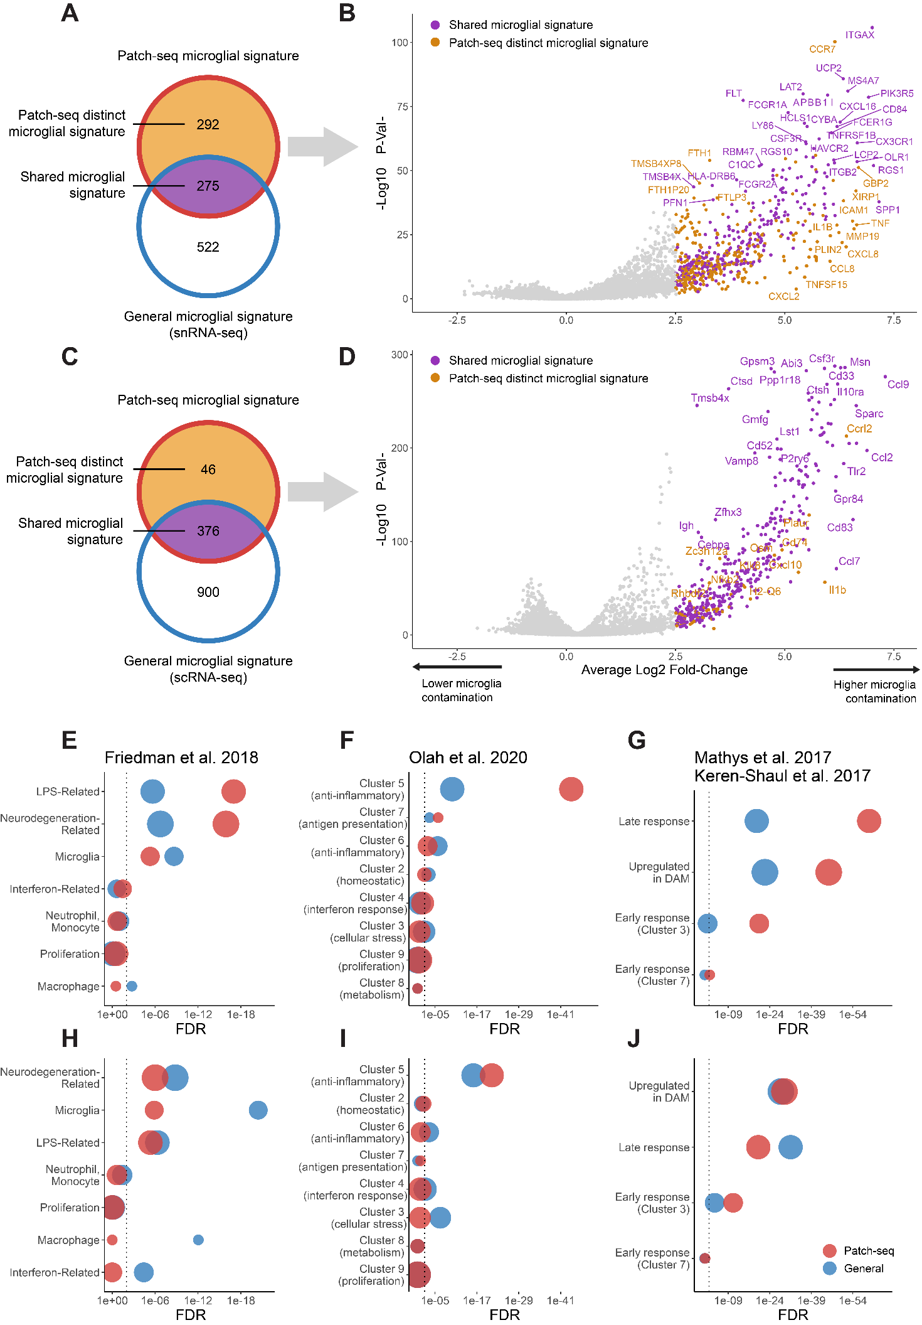

## Microglial contamination is associated with intrinsic electrophysiological variability between neurons

Given the widespread prevalence of microglial contamination in Patch-seq, we next wanted to assess whether such contamination might be associated with electrophysiological differences among sampled neurons. Because each neuron was first characterized for its intrinsic electrophysiological characteristics prior to mRNA harvesting, we were able to leverage this data to ask how microglial contamination might be associated with cell-to-cell variability in electrophysiological features.

For the purposes of illustration, we first considered a representative example of two human pyramidal cells (Figure 4B, D), one with low (0.06 microglia contamination score, Figure 4B, blue traces) and one with high microglial contamination (1.00 microglia contamination score, Figure 4B, red traces) but otherwise matched in their overall characteristics (same neurosurgical donor, neuron cell type, similar cortical depths [355 vs 331 um], etc). We observed a number of electrophysiological characteristics that strikingly differed between these two representative cells. For example, the more contaminated cell had a lower input resistance (96 vs 167 MOhms), greater rheobase (110 vs 70 pA), a more depolarized resting membrane potential (-67.8 vs -70.6 mV), and more depolarized action potential trough (-42.8 vs ​​-45.9) than the less contaminated cell, among other differences. Across human FREM3 pyramidal cells, we also saw that higher microglial contamination scores were associated with lower input resistances (Figure 4A, left, Pearson corr = -0.22 , p = 0.011) and more depolarized action potential through voltages (Figure 4A, left, Pearson corr = 0.17, p = 0.047). To help put these associations in context, microglial contamination explained 5.2% of the cell-to-cell variation in input resistance values among human FREM3 pyramidal cells. However, this value is similar to the variance in input resistance explained by the depth of the recorded neuron from the pial surface, 5.1%, noted previously to be a major biological factor distinguishing human superficial pyramidal cells from one another [(Berg et al., 2021; Kalmbach et al., 2018; Moradi Chameh et al., 2021)](https://www.zotero.org/google-docs/?P3hpS8).

To systematically quantify the association between microglial contamination and electrophysiological features, we used a statistical approach to ask how microglial contamination is associated with cell-to-cell variability in electrophysiological features, after controlling for other aspects of cellular and donor identity (see Methods). In human, we found increased microglial contamination associated with multiple electrophysiological features (Figure 4C). Most strikingly, we found that select subthreshold features, including input resistance and membrane sag, were associated with microglial contamination (Beta = -0.68, SE = ±0.19; Beta = 0.37 SE = ±0.21). In addition, a number of suprathreshold features, including action potential threshold and trough voltages, were also associated with microglial contamination (Beta = 0.59, SE = ±0.26; Beta = 0.65, SE = ±0.24). In general, associations were in consistent directions between human and mouse neurons, but the effects were more attenuated in the dataset of mouse neurons, perhaps due to its overall lower level of microglial contamination. We note that these statistical associations are merely correlational, however, given the temporal nature of Patch-seq, where electrophysiological features are recorded prior to mRNA harvest, it is plausible that these associations might reflect microglia-neuron crosstalk during the time of electrophysiological recording.

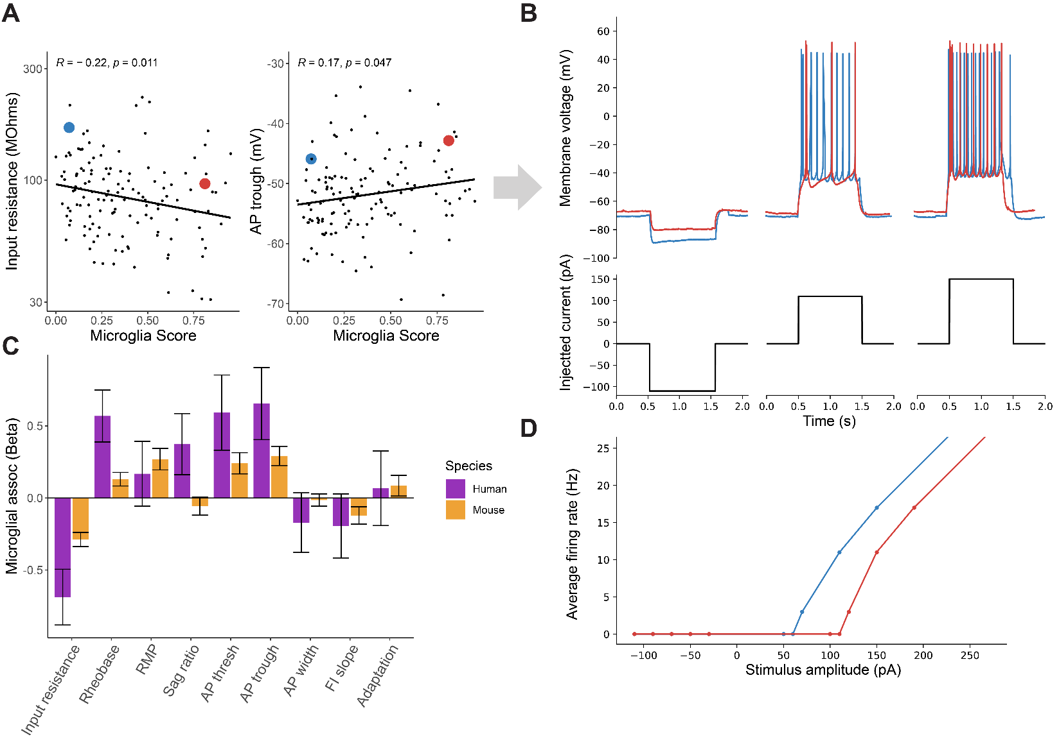

**Figure 4. *Microglial contamination is associated with altered neuronal intrinsic electrophysiology*. (A)** Scatter plots illustrating cellular input resistances (y-axis, left) and action potential trough (y-axis, right) versus microglial contamination scores (x-axis). Each dot reflects one human pyramidal cell sampled via Patch-seq. Inset blue and red dots reflect two pyramidal cells matched by neurosurgical donor, cell type (FREM3), and cortical depths, but with differing levels of transcriptomically-inferred microglial contamination. **(B)** Electrophysiological traces for neurons highlighted in A, reflecting different subthreshold (left) and suprathreshold (middle, right) characteristics of exemplar cells. **(C)** Association between microglial contamination and electrophysiological characteristics, as estimated using a mixed effects model. Bars indicate effect sizes (Beta coefficients), where negative (positive) beta coefficients indicate increased microglial contamination is associated with a decrease (increase) in the electrophysiological property. Electrophysiological features have been standardized to unit variance, enabling comparison of beta coefficient effect sizes between species. **(D)** Firing rate versus injected current (i.e., FI) curves for the two neurons highlighted in B.

# Discussion

Our analyses of two large-sample human and mouse Patch-seq datasets collected from acute brain slices suggest that microglial off-target contamination is widely present in the transcriptomes of the sampled neurons. A number of technical and biological factors were associated with microglial off-target contamination, including donor-specific factors, particularly in human neurosurgical biopsies, and neuronal cell type identity. Critically, microglial contamination is associated with altered neuronal electrophysiological features, including lowered input resistances and increased rheobase, and such changes are consistent with increased leak currents in these neurons. Lastly, the transcriptomic signature of microglial off-target contamination appears indicative of a distinct inflammatory and proliferating cell state.

While off-target cellular contamination in neuronal Patch-seq datasets has been reported previously, we were somewhat surprised by how prevalent it appeared in datasets analyzed here. Moreover, we were concerned that microglial contamination appeared to be a major contributor to unbiased clustering of Patch-seq derived neuronal transcriptomes. Microglial off-target contamination differed considerably in samples collected from different donors; in human datasets specifically, this might reflect the inherent challenges in obtaining biopsies from neurosurgical tissue, which we and others have suggested contributes to technical variability in efforts to systematically characterize human neurons in brain slices [(Moradi Chameh et al., 2021)](https://www.zotero.org/google-docs/?qaHl9I). Similarly, our analyses of different levels of observed microglial contamination among mouse neocortical interneurons might be reflective of differential vulnerability of these cell types to the influence of microglia *in vivo*. For example, we found that Pvalb Vipr2 cells, reflective of chandelier cells, appeared to display the most microglial contamination among all tested mouse neuronal types; intriguingly a recent report suggests that microglia are key regulators of chandelier cell axonal arborization and synapse formation [(Gallo et al., 2022)](https://www.zotero.org/google-docs/?hJL3Z2).

The transcriptional signature associated with the involvement of microglia in Patch-seq appeared indicative of activated microglia. This inference is based on the overexpression of key hallmark genes, such as *CCL2* and *CSF1*, and that the Patch-seq microglial transcriptional signature shares similarities with other microglia signatures related to LPS-, neurodegeneration, and disease associated microglia [(Friedman et al., 2018; Keren-Shaul et al., 2017; Mathys et al., 2017; Olah et al., 2020)](https://www.zotero.org/google-docs/?oiP5Ug). In addition, we note that we saw considerably more microglia-related genes distinct to human versus mouse Patch-seq datasets. While this might be reflective of bona fide species differences, one simple explanation for this finding might be related to our usage of single-nucleus RNAseq to provide reference profiles of microglia from humans but single-cell RNAseq from mice. Recently, it has been shown that single-nucleus RNAseq, when used to profile human microglia, might be more prone to missing important transcripts related to microglial proliferation and other disease related processes [(Thrupp et al., 2020)](https://www.zotero.org/google-docs/?qmna6G). Such transcripts are possibly expressed in distal cellular processes and such microglia cytoplasmic transcripts appear to be especially present in microglia inadvertently sampled during Patch-seq.

A key question our findings raise is how microglial contamination could contribute to altered cellular electrophysiology. We hypothesize two possible explanations that consider the order of events in Patch-seq, where cellular electrophysiology is characterized before mRNA is harvested and sequenced [(Lipovsek et al., 2021)](https://www.zotero.org/google-docs/?PdC8GN). First, we hypothesize that microglial processes might be physically interacting with the characterized neuron during patch-clamp electrophysiology. If such interactions tend to damage the cellular membranes, we reason that this might contribute to increased membrane leak currents and could explain the electrophysiological alterations observed here. A second alternative hypothesis is that microglia might be chemotaxing to unhealthy neurons, including those which have leaky cell membranes, but such neuron-microglia interactions might not be directly contributing to altered cellular electrophysiology. Because of the observational nature of our study, we cannot directly reconcile these competing explanations as doing so will likely require further experiments that directly perturb microglia.

Our study has a number of limitations. First, we note that our analyses rely on our ability to reliably infer the presence of microglial processes in proximity to the characterized neuron using transcriptomics [(Tripathy et al., 2018)](https://www.zotero.org/google-docs/?OU94GP). We feel reasonably confident in this inference as it is unlikely for neuronal cells to endogenously express tens of microglial specific markers and there is a reasonable concordance between microglial mRNA expression and microglia marker protein expression assayed via immunohistochemistry. Second, the analyses reflected here reflect experiments performed in a single large-lab (the Allen Institute for Brain Sciences) and may not necessarily generalize to experiments performed in other labs using alternative protocols. Lastly, we note that our analyses are observational in nature, relying on the natural variability inherent to different experiments. As such, it is difficult to conclude cause from effect in our study, for example, whether microglia-neuronal interactions directly contribute to increased neuronal leak currents.

Our study raises a number of questions on the nature of microglia-neuron interactions to be considered in the future. First and foremost, we need to better understand microglial proliferation in the context of work making use of acute brain slices in preparation for patch-clamp electrophysiology. What contributes to increased microglial proliferation in slices from some donors, but not others? And how can unwanted microglial proliferation be minimized in future experiments? Second, what is drawing microglia to neurons undergoing patch-clamp electrophysiology? Are microglial processes chemotaxing to the neuron’s soma (as opposed to its synapses or dendrites), and is this directly contributing to the large differences in neuronal intrinsic excitability reported here? Third, how is neuron health associated with microglial proliferation? Do unhealthy neurons release pro-inflammatory cytokines that draw microglia in? Or does microglia involvement directly cause neurons to become unhealthy, and ultimately display leakier cell membranes? These questions highlight an important potential role for microglia in shaping neuronal excitability and reflect a number of questions for future investigation.

# References

[Bachiller, S., Jiménez-Ferrer, I., Paulus, A., Yang, Y., Swanberg, M., Deierborg, T., and Boza-Serrano, A. (2018). Microglia in Neurological Diseases: A Road Map to Brain-Disease Dependent-Inflammatory Response. Front. Cell. Neurosci. *12*, 488. https://doi.org/10.3389/fncel.2018.00488.](https://www.zotero.org/google-docs/?xAA5or)

[Badimon, A., Strasburger, H.J., Ayata, P., Chen, X., Nair, A., Ikegami, A., Hwang, P., Chan, A.T., Graves, S.M., Uweru, J.O., et al. (2020). Negative feedback control of neuronal activity by microglia. Nature *586*, 417–423. https://doi.org/10.1038/s41586-020-2777-8.](https://www.zotero.org/google-docs/?xAA5or)

[Benmamar-Badel, A., Owens, T., and Wlodarczyk, A. (2020). Protective Microglial Subset in Development, Aging, and Disease: Lessons From Transcriptomic Studies. Front. Immunol. *11*, 430. https://doi.org/10.3389/fimmu.2020.00430.](https://www.zotero.org/google-docs/?xAA5or)

[Berg, J., Sorensen, S.A., Ting, J.T., Miller, J.A., Chartrand, T., Buchin, A., Bakken, T.E., Budzillo, A., Dee, N., Ding, S.-L., et al. (2020). Human cortical expansion involves diversification and specialization of supragranular intratelencephalic-projecting neurons. BioRxiv 2020.03.31.018820. https://doi.org/10.1101/2020.03.31.018820.](https://www.zotero.org/google-docs/?xAA5or)

[Burnham, K.P., and Anderson, D.R. (2010). Model selection and multimodel inference: a practical information-theoretic approach (New York, NY: Springer).](https://www.zotero.org/google-docs/?xAA5or)

[Butler, A., Hoffman, P., Smibert, P., Papalexi, E., and Satija, R. (2018). Integrating single-cell transcriptomic data across different conditions, technologies, and species. Nat. Biotechnol. *36*, 411–420. https://doi.org/10.1038/nbt.4096.](https://www.zotero.org/google-docs/?xAA5or)

[Cadwell, C.R., Scala, F., Li, S., Livrizzi, G., Shen, S., Sandberg, R., Jiang, X., and Tolias, A.S. (2017). Multimodal profiling of single-cell morphology, electrophysiology, and gene expression using Patch-seq. Nat. Protoc. *12*, nprot.2017.120. https://doi.org/10.1038/nprot.2017.120.](https://www.zotero.org/google-docs/?xAA5or)

[Cornell, J., Salinas, S., Huang, H.-Y., and Zhou, M. (2022). Microglia regulation of synaptic plasticity and learning and memory. Neural Regen. Res. *17*, 705. https://doi.org/10.4103/1673-5374.322423.](https://www.zotero.org/google-docs/?xAA5or)

[Durinck, S., Moreau, Y., Kasprzyk, A., Davis, S., De Moor, B., Brazma, A., and Huber, W. (2005). BioMart and Bioconductor: a powerful link between biological databases and microarray data analysis. Bioinformatics *21*, 3439–3440. https://doi.org/10.1093/bioinformatics/bti525.](https://www.zotero.org/google-docs/?xAA5or)

[Durinck, S., Spellman, P.T., Birney, E., and Huber, W. (2009). Mapping identifiers for the integration of genomic datasets with the R/Bioconductor package biomaRt. Nat. Protoc. *4*, 1184–1191. https://doi.org/10.1038/nprot.2009.97.](https://www.zotero.org/google-docs/?xAA5or)

[Erblich, B., Zhu, L., Etgen, A.M., Dobrenis, K., and Pollard, J.W. (2011). Absence of Colony Stimulation Factor-1 Receptor Results in Loss of Microglia, Disrupted Brain Development and Olfactory Deficits. PLoS ONE *6*, e26317. https://doi.org/10.1371/journal.pone.0026317.](https://www.zotero.org/google-docs/?xAA5or)

[Federico, A., and Monti, S. (2020). hypeR: an R package for geneset enrichment workflows. Bioinformatics *36*, 1307–1308. https://doi.org/10.1093/bioinformatics/btz700.](https://www.zotero.org/google-docs/?xAA5or)

[Friedman, B.A., Srinivasan, K., Ayalon, G., Meilandt, W.J., Lin, H., Huntley, M.A., Cao, Y., Lee, S.-H., Haddick, P.C.G., Ngu, H., et al. (2018). Diverse Brain Myeloid Expression Profiles Reveal Distinct Microglial Activation States and Aspects of Alzheimer’s Disease Not Evident in Mouse Models. Cell Rep. *22*, 832–847. https://doi.org/10.1016/j.celrep.2017.12.066.](https://www.zotero.org/google-docs/?xAA5or)

[Gallo, N.B., Berisha, A., and Van Aelst, L. (2022). Microglia regulate chandelier cell axo-axonic synaptogenesis. Proc. Natl. Acad. Sci. *119*, e2114476119. https://doi.org/10.1073/pnas.2114476119.](https://www.zotero.org/google-docs/?xAA5or)

[Ginhoux, F., Lim, S., Hoeffel, G., Low, D., and Huber, T. (2013). Origin and differentiation of microglia. Front. Cell. Neurosci. *7*. https://doi.org/10.3389/fncel.2013.00045.](https://www.zotero.org/google-docs/?xAA5or)

[Gouwens, N.W., Sorensen, S.A., Berg, J., Lee, C., Jarsky, T., Ting, J., Sunkin, S.M., Feng, D., Anastassiou, C.A., Barkan, E., et al. (2019). Classification of electrophysiological and morphological neuron types in the mouse visual cortex. Nat. Neurosci. *22*, 1182–1195. https://doi.org/10.1038/s41593-019-0417-0.](https://www.zotero.org/google-docs/?xAA5or)

[Gouwens, N.W., Sorensen, S.A., Baftizadeh, F., Budzillo, A., Lee, B.R., Jarsky, T., Alfiler, L., Baker, K., Barkan, E., Berry, K., et al. (2020). Integrated Morphoelectric and Transcriptomic Classification of Cortical GABAergic Cells. Cell *183*, 935-953.e19. https://doi.org/10.1016/j.cell.2020.09.057.](https://www.zotero.org/google-docs/?xAA5or)

[Hodge, R.D., Bakken, T.E., Miller, J.A., Smith, K.A., Barkan, E.R., Graybuck, L.T., Close, J.L., Long, B., Johansen, N., Penn, O., et al. (2019). Conserved cell types with divergent features in human versus mouse cortex. Nature *573*, 61–68. https://doi.org/10.1038/s41586-019-1506-7.](https://www.zotero.org/google-docs/?xAA5or)

[Kalmbach, B., Buchin, A., Miller, J.A., Bakken, T.E., Hodge, R.D., Chong, P., Frates, R. de, Dai, K., Gwinn, R.P., Cobbs, C., et al. (2018). h-channels contribute to divergent electrophysiological properties of supragranular pyramidal neurons in human versus mouse cerebral cortex. BioRxiv 312298. https://doi.org/10.1101/312298.](https://www.zotero.org/google-docs/?xAA5or)

[Keren-Shaul, H., Spinrad, A., Weiner, A., Matcovitch-Natan, O., Dvir-Szternfeld, R., Ulland, T.K., David, E., Baruch, K., Lara-Astaiso, D., Toth, B., et al. (2017). A Unique Microglia Type Associated with Restricting Development of Alzheimer’s Disease. Cell *169*, 1276-1290.e17. https://doi.org/10.1016/j.cell.2017.05.018.](https://www.zotero.org/google-docs/?xAA5or)

[Koss, K., Churchward, M.A., Tsui, C., and Todd, K.G. (2019). In Vitro Priming and Hyper-Activation of Brain Microglia: an Assessment of Phenotypes. Mol. Neurobiol. *56*, 6409–6425. https://doi.org/10.1007/s12035-019-1529-y.](https://www.zotero.org/google-docs/?xAA5or)

[Lee, B.R., Budzillo, A., Hadley, K., Miller, J.A., Jarsky, T., Baker, K., Hill, D., Kim, L., Mann, R., Ng, L., et al. (2021a). Scaled, high fidelity electrophysiological, morphological, and transcriptomic cell characterization. ELife *10*, e65482. https://doi.org/10.7554/eLife.65482.](https://www.zotero.org/google-docs/?xAA5or)

[Lehrman, E.K., Wilton, D.K., Litvina, E.Y., Welsh, C.A., Chang, S.T., Frouin, A., Walker, A.J., Heller, M.D., Umemori, H., Chen, C., et al. (2018). CD47 Protects Synapses from Excess Microglia-Mediated Pruning during Development. Neuron *100*, 120-134.e6. https://doi.org/10.1016/j.neuron.2018.09.017.](https://www.zotero.org/google-docs/?xAA5or)

[Lipovsek, M., Browne, L., and Grubb, M.S. (2020). Protocol for Patch-Seq of Small Interneurons. STAR Protoc. *1*, 100146. https://doi.org/10.1016/j.xpro.2020.100146.](https://www.zotero.org/google-docs/?xAA5or)

[Liu, T., Zhang, L., Joo, D., and Sun, S.-C. (2017). NF-κB signaling in inflammation. Signal Transduct. Target. Ther. *2*, 17023. https://doi.org/10.1038/sigtrans.2017.23.](https://www.zotero.org/google-docs/?xAA5or)

[Marsh, S.E., Walker, A.J., Kamath, T., Dissing-Olesen, L., Hammond, T.R., de Soysa, T.Y., Young, A.M.H., Murphy, S., Abdulraouf, A., Nadaf, N., et al. (2022). Dissection of artifactual and confounding glial signatures by single-cell sequencing of mouse and human brain. Nat. Neurosci. *25*, 306–316. https://doi.org/10.1038/s41593-022-01022-8.](https://www.zotero.org/google-docs/?xAA5or)

[Mathys, H., Adaikkan, C., Gao, F., Young, J.Z., Manet, E., Hemberg, M., De Jager, P.L., Ransohoff, R.M., Regev, A., and Tsai, L.-H. (2017). Temporal Tracking of Microglia Activation in Neurodegeneration at Single-Cell Resolution. Cell Rep. *21*, 366–380. https://doi.org/10.1016/j.celrep.2017.09.039.](https://www.zotero.org/google-docs/?xAA5or)

[Monat, C., Padmarasu, S., Lux, T., Wicker, T., Gundlach, H., Himmelbach, A., Ens, J., Li, C., Muehlbauer, G.J., Schulman, A.H., et al. (2019). TRITEX: chromosome-scale sequence assembly of Triticeae genomes with open-source tools. Genome Biol. *20*, 284. https://doi.org/10.1186/s13059-019-1899-5.](https://www.zotero.org/google-docs/?xAA5or)

[Moradi Chameh, H., Rich, S., Wang, L., Chen, F.-D., Zhang, L., Carlen, P.L., Tripathy, S.J., and Valiante, T.A. (2021). Diversity amongst human cortical pyramidal neurons revealed via their sag currents and frequency preferences. Nat. Commun. *12*, 2497. https://doi.org/10.1038/s41467-021-22741-9.](https://www.zotero.org/google-docs/?xAA5or)

[Nakagawa, S., Johnson, P.C.D., and Schielzeth, H. The coefficient of determination R2 and intra-class correlation coefficient from generalized linear mixed-effects models revisited and expanded. 11. .](https://www.zotero.org/google-docs/?xAA5or)

[Olah, M., Menon, V., Habib, N., Taga, M.F., Ma, Y., Yung, C.J., Cimpean, M., Khairallah, A., Coronas-Samano, G., Sankowski, R., et al. (2020). Single cell RNA sequencing of human microglia uncovers a subset associated with Alzheimer’s disease. Nat. Commun. *11*, 6129. https://doi.org/10.1038/s41467-020-19737-2.](https://www.zotero.org/google-docs/?xAA5or)

[Pallio, G., D’Ascola, A., Cardia, L., Mannino, F., Bitto, A., Minutoli, L., Picciolo, G., Squadrito, V., Irrera, N., Squadrito, F., et al. (2021). MAO-A Inhibition by Metaxalone Reverts IL-1β-Induced Inflammatory Phenotype in Microglial Cells. Int. J. Mol. Sci. *22*, 8425. https://doi.org/10.3390/ijms22168425.](https://www.zotero.org/google-docs/?xAA5or)

[Pan, Y.-B., Sun, Y., Li, H.-J., Zhou, L.-Y., Zhang, J., and Feng, D.-F. (2022). Transcriptome Analyses Reveal Systematic Molecular Pathology After Optic Nerve Crush. Front. Cell. Neurosci. *15*, 800154. https://doi.org/10.3389/fncel.2021.800154.](https://www.zotero.org/google-docs/?xAA5or)

[Scala, F., Kobak, D., Bernabucci, M., Bernaerts, Y., Cadwell, C.R., Castro, J.R., Hartmanis, L., Jiang, X., Laturnus, S., Miranda, E., et al. (2020). Phenotypic variation of transcriptomic cell types in mouse motor cortex. Nature 1–7. https://doi.org/10.1038/s41586-020-2907-3.](https://www.zotero.org/google-docs/?xAA5or)

[Sellgren, C.M., Sheridan, S.D., Gracias, J., Xuan, D., Fu, T., and Perlis, R.H. (2017). Patient-specific models of microglia-mediated engulfment of synapses and neural progenitors. Mol. Psychiatry *22*, 170–177. https://doi.org/10.1038/mp.2016.220.](https://www.zotero.org/google-docs/?xAA5or)

[Spencer, N.G., Schilling, T., Miralles, F., and Eder, C. (2016). Mechanisms Underlying Interferon-γ-Induced Priming of Microglial Reactive Oxygen Species Production. PLOS ONE *11*, e0162497. https://doi.org/10.1371/journal.pone.0162497.](https://www.zotero.org/google-docs/?xAA5or)

[Stuart, T., Butler, A., Hoffman, P., Hafemeister, C., Papalexi, E., Mauck, W.M., Hao, Y., Stoeckius, M., Smibert, P., and Satija, R. (2019). Comprehensive Integration of Single-Cell Data. Cell *177*, 1888-1902.e21. https://doi.org/10.1016/j.cell.2019.05.031.](https://www.zotero.org/google-docs/?xAA5or)

[Tasic, B., Yao, Z., Graybuck, L.T., Smith, K.A., Nguyen, T.N., Bertagnolli, D., Goldy, J., Garren, E., Economo, M.N., Viswanathan, S., et al. (2018). Shared and distinct transcriptomic cell types across neocortical areas. Nature *563*, 72–78. https://doi.org/10.1038/s41586-018-0654-5.](https://www.zotero.org/google-docs/?xAA5or)

[Thrupp, N., Sala Frigerio, C., Wolfs, L., Skene, N.G., Fattorelli, N., Poovathingal, S., Fourne, Y., Matthews, P.M., Theys, T., Mancuso, R., et al. (2020). Single-Nucleus RNA-Seq Is Not Suitable for Detection of Microglial Activation Genes in Humans. Cell Rep. *32*, 108189. https://doi.org/10.1016/j.celrep.2020.108189.](https://www.zotero.org/google-docs/?xAA5or)

[Tripathy, S.J., Toker, L., Bomkamp, C., Mancarci, B.O., Belmadani, M., and Pavlidis, P. (2018). Assessing Transcriptome Quality in Patch-Seq Datasets. Front. Mol. Neurosci. *11*, 363. https://doi.org/10.3389/fnmol.2018.00363.](https://www.zotero.org/google-docs/?xAA5or)

[Wang, C., Yue, H., Hu, Z., Shen, Y., Ma, J., Li, J., Wang, X.-D., Wang, L., Sun, B., Shi, P., et al. (2020). Microglia mediate forgetting via complement-dependent synaptic elimination. Science *367*, 688–694. https://doi.org/10.1126/science.aaz2288.](https://www.zotero.org/google-docs/?xAA5or)

[Yamamoto, M., Kim, M., Imai, H., Itakura, Y., and Ohtsuki, G. (2019). Microglia-Triggered Plasticity of Intrinsic Excitability Modulates Psychomotor Behaviors in Acute Cerebellar Inflammation. Cell Rep. *28*, 2923-2938.e8. https://doi.org/10.1016/j.celrep.2019.07.078.](https://www.zotero.org/google-docs/?xAA5or)

[Yamawaki, Y., Wada, Y., Matsui, S., and Ohtsuki, G. (2022). Microglia-triggered hypoexcitability plasticity of pyramidal neurons in the rat medial prefrontal cortex. Curr. Res. Neurobiol. *3*, 100028. https://doi.org/10.1016/j.crneur.2022.100028.](https://www.zotero.org/google-docs/?xAA5or)

Yao, Z., van Velthoven, C.T.J., Nguyen, T.N., Goldy, J., Sedeno-Cortes, A.E., Baftizadeh, F., Bertagnolli, D., Casper, T., Chiang, M., Crichton, K., et al. (2021). A taxonomy of transcriptomic cell types across the isocortex and hippocampal formation. Cell *184*, 3222-3241.e26. https://doi.org/10.1016/j.cell.2021.04.021.

# Supplemental

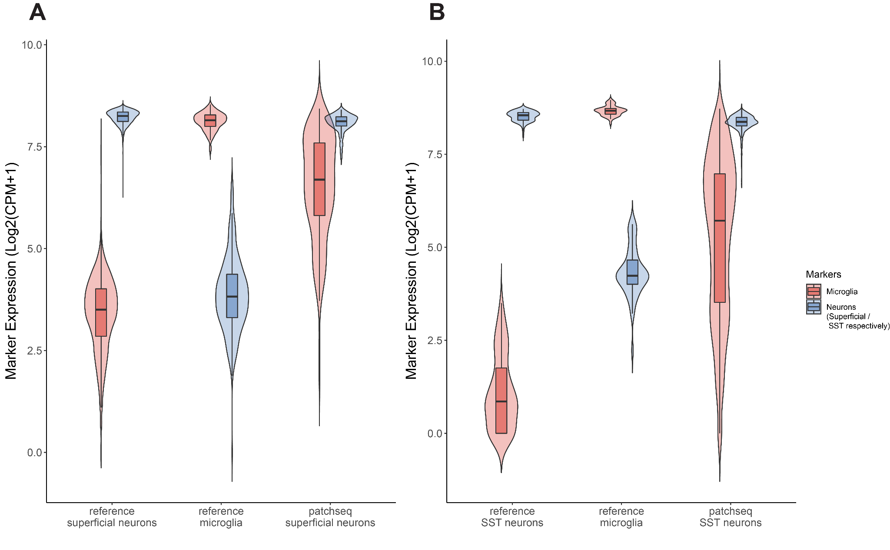

**Supplementary Figure 1. *Expression of microglial marker genes in Patch-seq datasets approaches levels measured in microglia from reference single-cell datasets.*** Summed expression of cell type-specific marker genes for human superficial glutamatergic neurons **(A)** or mouse SST interneurons **(B)** and microglia compared across respective cell populations in Patch-seq and equivalent scRNA-seq datasets.

**Supplementary Table 1. *Human Patch-seq differential expression between cells with high vs. low microglial contamination***

[***https://docs.google.com/spreadsheets/d/1Wv4K5HsDE5ZDu4dIggk0AHCBZBpgMLiGPEIouWLsKNo/edit?usp=sharing***](https://docs.google.com/spreadsheets/d/1Wv4K5HsDE5ZDu4dIggk0AHCBZBpgMLiGPEIouWLsKNo/edit?usp=sharing)

**Supplementary Table 2. *Mouse Patch-seq differential expression between cells with high vs. low microglial contamination***

[***https://docs.google.com/spreadsheets/d/1filofRdobKlf8kAPwwONaYJ8_luKzdZ9UYhnUhQ9dG0/edit?usp=sharing***](https://docs.google.com/spreadsheets/d/1filofRdobKlf8kAPwwONaYJ8_luKzdZ9UYhnUhQ9dG0/edit?usp=sharing)

**Available code:**

[***https://github.com/keon-arbabi/patch-seq-microglia.git***](https://github.com/keon-arbabi/patch-seq-microglia.git)